The Social Cohesion Resources Document

Thank you firstly for taking the time to research, understand and process the events currently taking place. By reading this you are beginning or continuing your journey of awareness and personal inclusion. Marginalised identities across the globe have faced challenges regarding politics, cooperate environments, personal environments and societal attitudes.
While George Floyd’s death echoed all over the world, it may come as no surprise to you that this instance is not isolated and not exclusive to America.
What you can gain from this document is a wealth of opportunities to learn data, the research, history and indeed current cultural affairs surrounding black identity, and the role other races play in conjunction with it.
This is a resource page, and so I will link you to the items with reasons as to what it offers.

BOOKS:
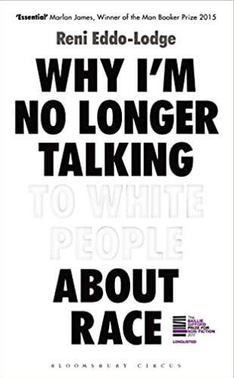
Why I’m No Longer Talking to White People About Race – Reni Eddo-Lodge
Link - https://g.co/kgs/jBVgxz
Audiobook Available
The opening statement of the book alone could be the whole book. It was the statement that sparked the necessity for the book. A lot of the world’s perceived racism can be viewed as centered in America. What this book does is give history and voice the historical black experience in the UK, creating a clear timeline from the early century to today. This book is important for people, particularly in the UK, who believe that “we don’t really get racism here”.

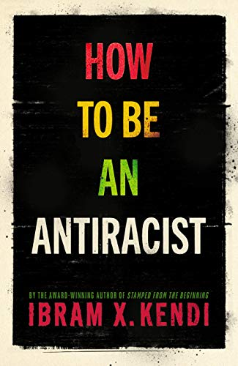
How to Be an Anti-Racist – Ibram X Kendi
Link - https://www.amazon.co.uk/How-to-Be-an-Antiracist/dp/B07W81KR3S
Audiobook Available
Currently working my way through this book, Ibram clearly lays out the emptiness of simply being “not racist” and how flaccid that notion is. Anti-racism is descripted as an actionable, reinforceable energy, that takes us from silence to discourse, which ultimately brings us much closer to positive change.
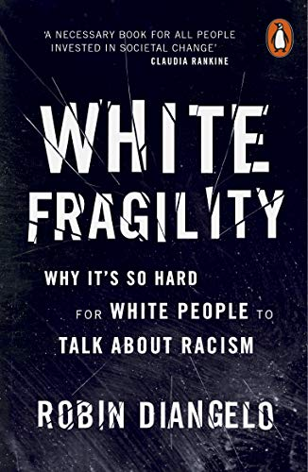
White Fragility: Why It's So Hard for White People to Talk About Racism – Robin DiAngelo
Link - https://www.amazon.co.uk/dp/B07N961MC8/ref=cm_sw_em_r_mt_dp_U_EHp2Eb3NSZQY5
Audiobook Available
White Fragility goes into the details behind why white people are often left out of the conversation about the very thing their ancestors created and built nations on, and why white people can indeed become uncomfortable in the conversation. This book plays a key role for all people, to understand would could be happening when our privileges, even outside of a racial structure, are brought to question. While it does have a focus on race, I found myself relating to the book in regards to my own male, straight privilege.
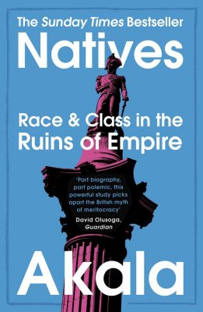
Natives: Race and Class in the Ruins of an Empire - Akala
Link - https://www.amazon.co.uk/dp/B076HZ7MT7/ref=cm_sw_em_r_mt_dp_U_zTp2EbPN9XAK4
Audiobook Available
As suggested in the title, Akala’s intellect shines truly in both a racial and class based take on British history. Asking some deep, thought provoking questions that made me realise how shorted sighted I had been about some key points I’d learned in history. How realistic is it really that it only took one British man to “end slavery” in the UK, when a great deal of business and financial gain to the nation came from slavery. Surely he had help… but why don’t we hear about that?
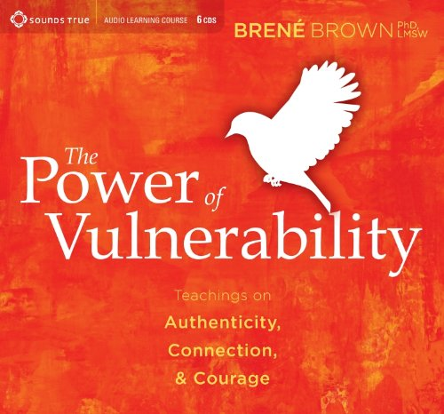
The Power of Vulnerability – Brene Brown
Link - https://www.amazon.co.uk/dp/1604078588/ref=cm_sw_em_r_mt_dp_U_T1p2EbNJSYRW4
Audiobook Available
At first, it feels like odd book to put in the list, but Brene’s work has always reflected a hint of social equality and equity with regards to how we hold ourselves in difference, how we challenge ourselves through growth and how we care for ourselves in adversity. I had been told that Brene’s work was designed for women, however, having already listened to this audiobook, I found myself in a strengthened place of empathy and openness. I recommend this book to anyone and everyone, as it sets a great foundation for how to move forward through these challenging times.
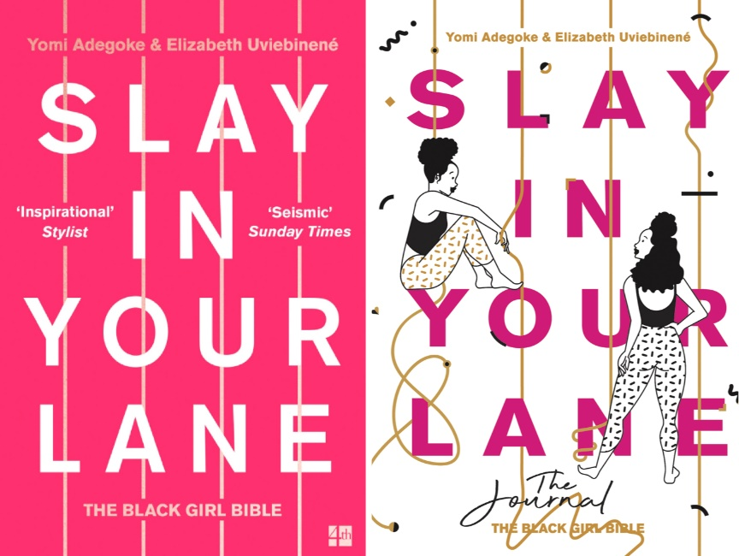
Slay in your Lane: The Black Girl Bible – Elizabeth Uviebinene, Yomi Adegoke
Link - https://www.amazon.co.uk/dp/0008235627/ref=cm_sw_em_r_mt_dp_U_B9p2EbXCXJ25Z
Audiobook Available
Stories about black history have always come across as more visceral to me, and so it was with curious delight that I listened to Slay in your Lane. Elizabeth and Yomi take the conversation to a more focused side of history, looking at black women. While it black men who are more often shot, imprisoned or killed around the world, black women are left with more than loss. They can be left with families, left alone and left to build for themselves. This focus, allows for nuanced thinking, and hopes to bridge the gap intersecting between black lives, and black women’s lives.
BOOKS I HAVE YET TO READ:
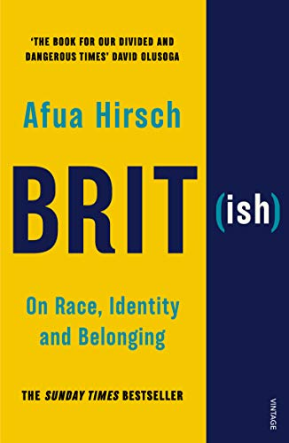
BRIT(ish) – Afua Hirsch
Link - https://www.amazon.co.uk/dp/1784705039/ref=cm_sw_em_r_mt_dp_U_Xcq2EbVW9E620
Audiobook Available
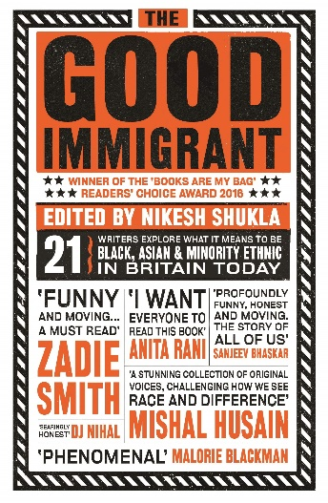
Good Immigrant – Nikesh Shukla
Link – https://www.amazon.co.uk/dp/1783523956/ref=cm_sw_em_r_mt_dp_U_Fjq2Eb72KVSBN
Audiobook Available

PODCASTS:
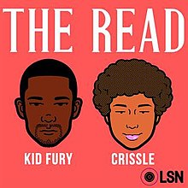
The Read
https://g.co/kgs/HH9xNU
This unapologetic, fiery and lively podcast takes itself very seriously whilst also being entertaining as hell. Proudly speaking out for not just black people, but LGBT black people inclusively, if you’re comfortable with the idea of feeling white/straight/male guilt, and open to learn and listen, then these episodes serve a punch bowl with a lot of hard liquor.
Food4Thot
Link - https://food4thotpodcast.com/
With a primary focus on the T and Q of LGBTQ, these are 4 transracial, transgender people from New York. Poets, scientists, writers sit around a table, usually with Rose wine, to discuss all things racial, sexual (sometimes INCREDIBLY sexual which is a heads up), cultural and spiritual. I recommend this podcast for the strong of heart and soul, as the topics in this podcast deep, insightful, spiritual and explicit.
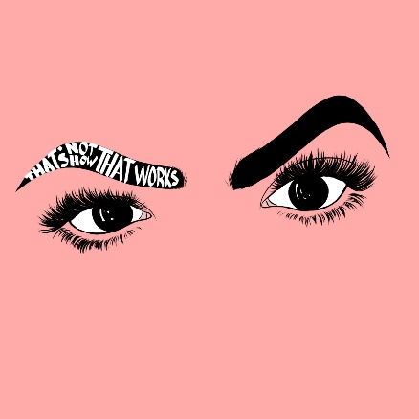
That’s Not How That Works
Link - www.nothowthatworks.com
Trudi and Weezy join their individual unstoppable forces to discuss all things identity in this coaching based series of call outs to what is going wrong with the coaching industry, as well as out on the streets. They have been known to have a guest or two on to bring their expertise, however, each episode brings it’s own unique flavour of education, spanning from privileges to safe spaces to “reverse racism” and so on.
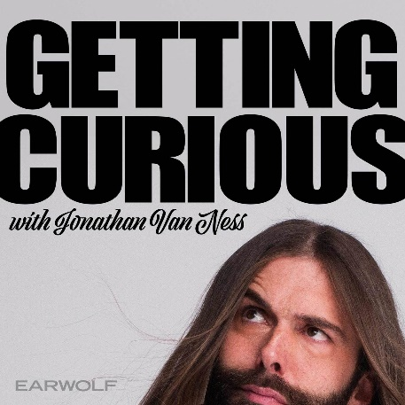
Getting Curious with Jonathan Van Ness
Link –
Just the number of times alone I heard people tell me that JVN is their favourite “Queer Eye” host, matches the amount I admire them. Jonathan brings his true unforgettable energy to this show, covering a wide range of social topics, bringing in experts from all over the world to dig deeper into them. There are some notable episodes posted include “How Do the Legacies of Slavery and Jim Crow Laws Still Affect Americans Today?”. They are always inclusive on the show, and shout out nuance to topics that affect different individuals in different ways.
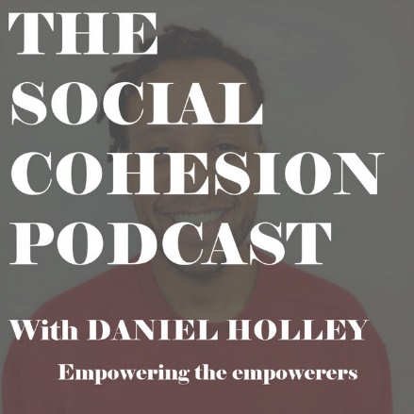
The Social Cohesion Podcast
Link - https://open.spotify.com/show/1v6ZaqxEfiL5Xf3s8Y7MXW (Also available on Apple Podcasts and Stitcher)
I created this podcast at first to have challenging conversations about taboo subjects, but quickly changed the format to something more unique. I coach individuals on the podcast, around an area the coachee wishes to cover. It is an example of how a person challenges theirselves, opens up new opportunities and is facilitated through a process of creating a positive future. What does this have to do with social cohesion? I empower individuals based on their values. Not their income, their interests or their character. If their values reflect that of an inclusive, equality based world, then I coach them.

SOCIAL MEDIA:
I’ll start by recommending you follow people by hash-tagging certain phrases connected to equality, equity, peace or of course the black lives matter movement.
Next to suggest is what I call Social Media Surgery.
Instead of connecting you with pages to follow and people to follow, what I strongly suggest is seeking them out. This is advised because in order to truly perform the correct work, you would not only need to find the appropriate pages/people to follow but you’d also need to seed through your current feeds and weed out the pages that are not really serving your intention. Of course, the meme pages and joke pages are allowed, but ask yourself consciously, do they have a track record of perpetuating any of the following to as little as a mild degree:
Racial/Gender stereotypes
Transphobia
Sexism
Racism
Misogynoir (discrimination against black and POC women specifically)
Aggressive anti-white narratives (calls for violence and harm towards white people)
Gaslighting (suggesting that people’s realities are not their realities)
This is important to note as there is a track record of meme/joke pages being inadvertent grooming areas for white supremacy and bigotry.

TV SHOWS AND DOCUMENTARIES
NOTE: The following TV shows and documentaries is not an exhaustive list, but is a list of impactful and deeply moving shows recommended to reinforce your journey towards Social Cohesion. Be sure to check for recommendations made.
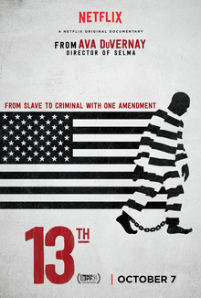
13th – Documentary - Netflix
Link - https://www.netflix.com/title/80091741
Informative and somewhat rage inducing documentary about the transferral of the slave trade to the prison service.
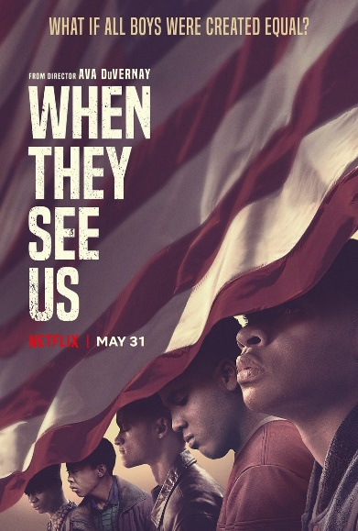
When They See Us – Netflix
Link - https://www.netflix.com/title/80200549
Heavy hitting docu-film about the Central Park 5. Covering the lives of 5 young black men caught in the wrong place at the wrong time, how the justice system failed them and how current popular leaders stoked the fires of their demise.

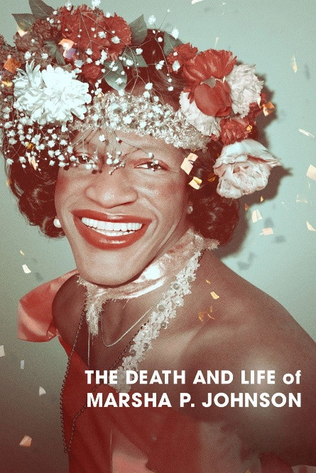
The Death and Life of Marsha P Johnson – Netflix
Link - https://www.netflix.com/title/80189623
Setting a strong example to future generations of LGBTQ people, Marsha P Johnson is the representation of the knowledge that Pride would not be without black trans people, and black culture would not be what it is, without black trans people.
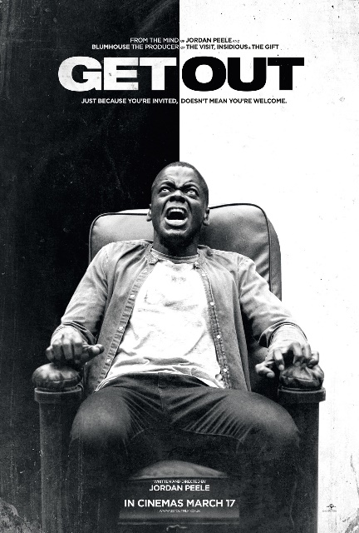
Get Out – Available on multiple platforms
Link - https://g.co/kgs/Ckqwzu
Seems an obvious pick, but a second and third viewing of this film uncovers the racially nuanced direction from Jordan Peele which is only experienced through the lens of racial education and understanding. At the same time, the clear surface level narrative of the commodification of black bodies, running parallel to the seeming disposability of black bodies makes this film an repeatable feast.
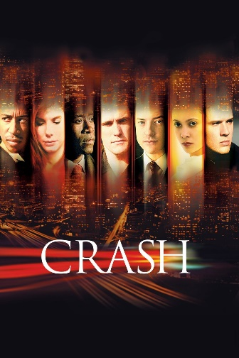
Crash – Available on multiple platforms
Link - https://g.co/kgs/3yufE3
Having watched this over a decade ago, the details are somewhat lost on me, but the impact of racial and gender based tensions still linger. This is a film that attempts to take a journey through the identity discourse, and based on the fact that it still lingers, it stays on this list.

SHOWS I AM YET TO SEE
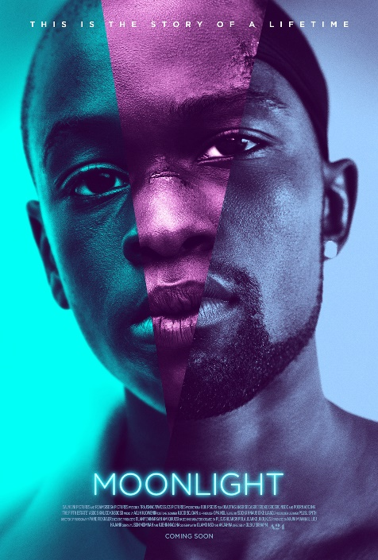
Moonlight – Movie available on multiple platforms
Link - https://g.co/kgs/X77vNk
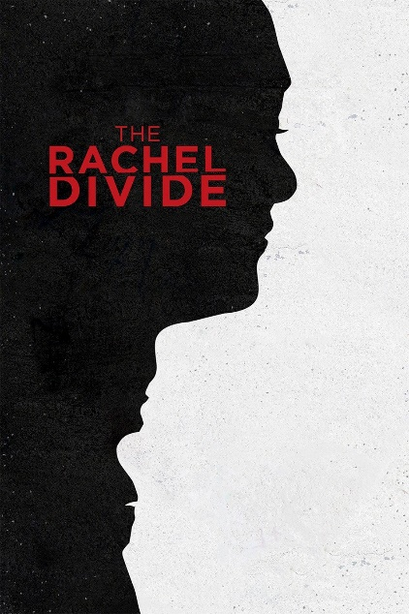
The Rachel Divide – Netflix
Link - https://www.netflix.com/title/80149821

